**Waterfront Guidelines and Regulations for HOLA Members with Waterfront Rights**

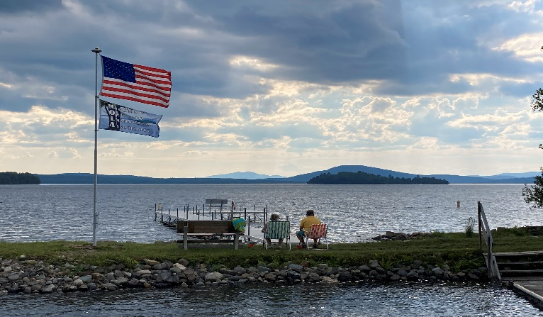

**The HOLA Board wishes to help each of us keep our property values high and maintenance costs low. This list of Board approved regulations is to enhance everyone’s enjoyment and to summarize the key rules regarding the usage of our common HOLA waterfront property.**

* Our waterfront is HOLA property. Be respectful of others, especially in the presence of families with children.
* Members, families, and guests shall have full use of the waterfront.
* **Swim at your own risk. There is no lifeguard on duty.**
* Children under age 16 must be accompanied by an adult.
* **Dogs are welcome, but must be under the owner’s control at all times and must be cleaned up after. Dogs are NOT permitted in the swimming area or on the aluminum docks.**
* **No ATV’s are allowed at the waterfront.**
* No smoking.
* Swimming within the boat harbor is prohibited.
* No trash should be left on the waterfront property.
* **The aluminum docks are to be used for entering and exiting the lake. They are NOT to be used as a place to set up chairs, tables, etc.**
* Quiet hours for the Town of Rangeley are 10 PM to 7 AM.
* Fireworks are NOT permitted at the waterfront.

**Rules for Motorboats in the Waterfront Harbor**

* HOLA is not responsible for any craft left or stored at the waterfront.
* **Boats are NOT allowed to tie up, pick up passengers, or land on any of the aluminum docks.**
* **Due to Milfoil concerns and the limited size of our harbor, renters cannot launch or tie up their boats within the HOLA Harbor. Renters with boats are to be directed to the Town Park to launch their boats as it is a much easier launch and the RLHT is screening for Milfoil.**
* Pontoon boats are NOT allowed in the HOLA harbor.
* Boat trailers cannot be parked at the waterfront overnight.
* Forms for HOLA residents to apply for a motorboat slip will be sent out on October 1, along with the annual HOLA bills. The forms must be completely filled out and returned to the Harbormaster.  The slips will be assigned on a “first come-first served” basis.  Applicants will be informed of the status of their application by the Harbormaster in December.
* If a watercraft is in a slip not assigned to it, the Harbormaster or member of the Waterfront Committee shall have the right to remove the watercraft at the owner’s expense and peril.

**Rules for Kayaks, Canoes and Paddleboards**

* HOLA is not responsible for any craft put on the rack.
* The “kayak” racks may hold canoes, kayaks or paddleboards.
* There are fifty-four (54) racks available.
* Forms for HOLA residents to apply for a rack will be sent out on October 1, along with the annual HOLA bills. The forms must be completely filled out and returned to the Harbormaster.  The racks will be assigned on a “first come-first served” basis.  Applicants will be informed of the status of their application by the Harbormaster in December.
* Individuals may apply for one or two kayak rack slots.
* **A single rack or slot may hold two kayaks or paddleboards only if they fit securely; are not hanging half off the rack or partially on the ground.**
* **Each craft must have a name and phone number on it.**
* These racks are for the use of HOLA members. Racks can not be requested for use by renters or guests.
* Crafts should be tied down onto the rack.
* If a rack remains empty through the month of June, the Harbormaster will contact the individual and possibly reassign the rack to someone else.
* No crafts can be left on the ground.
* If a watercraft is on a rack not assigned to it, or left on the ground, the Harbormaster or member of the Waterfront Committee shall have the right to remove the watercraft at the owner’s expense and peril.